Power BI Assignment 1 – Data Transformation & Data Modelling
Power BI Assignment focuses on transforming raw data into a clean, structured format using Power Query techniques such as removing duplicates, handling missing values, and applying column transformations. It also introduces essential data modelling concepts, including creating relationships, defining data types, and building a logical model for analysis. Through this assignment, learners understand how to prepare datasets for accurate reporting and build a strong foundation for dashboards. The task strengthens practical skills in shaping data and designing efficient models for real-world business insights.
Tools & Technologies Used:
- Microsoft Power BI Desktop
- Power Query Editor
- CSV Data Files

Objective: To transform, clean, and structure e-commerce sales data in Power BI, creating an optimized data model that supports accurate analysis of sales performance, profitability, customer behaviour, and target achievement.

Data Transformation Process – Step-by-Step Explanation

- Importing Data:

Importing the Data into Power Query Editor and Power BI

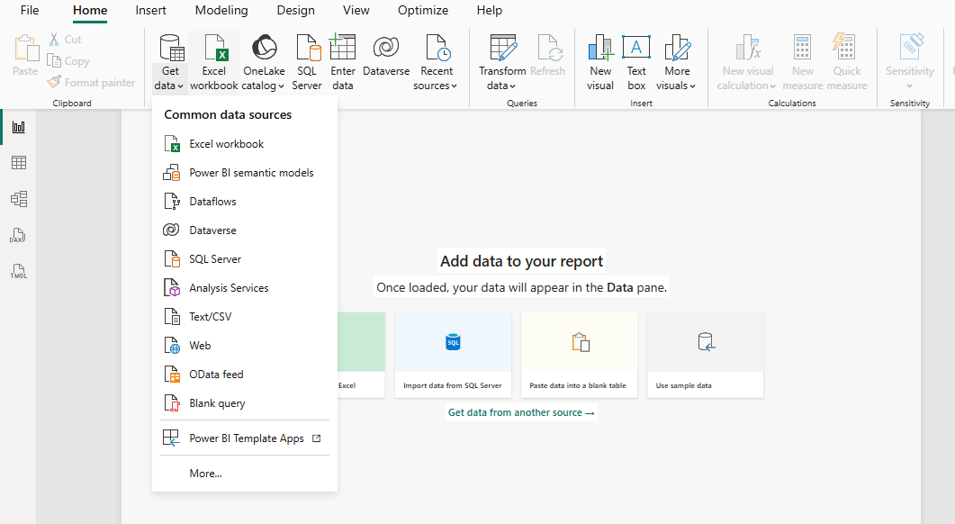
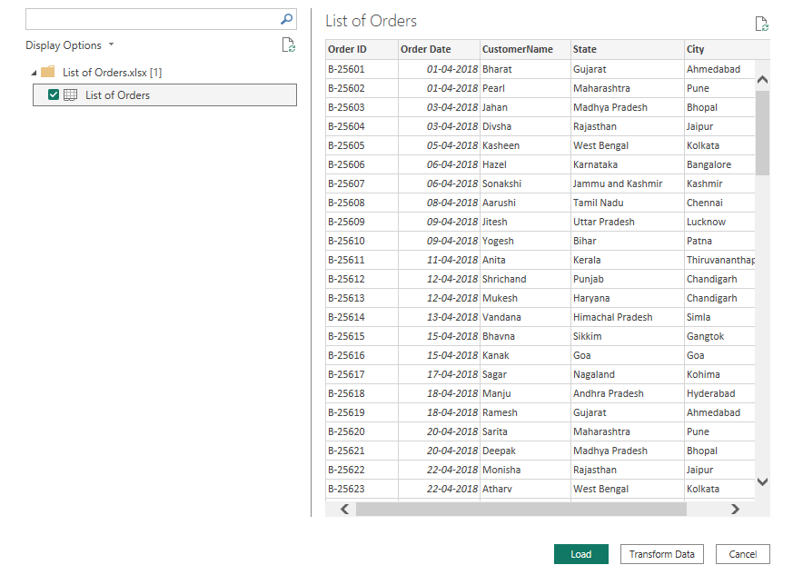

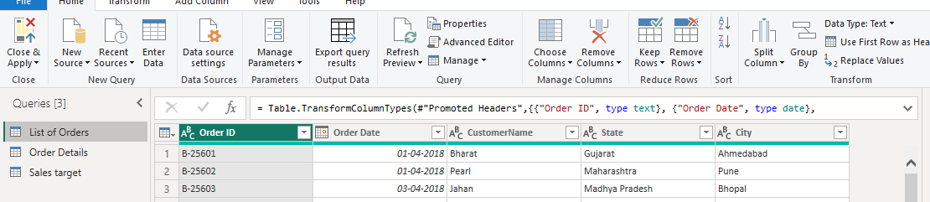

- Restrict the "List of Orders" table to only the first 500 rows.
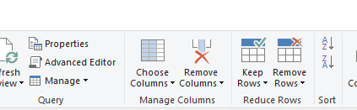
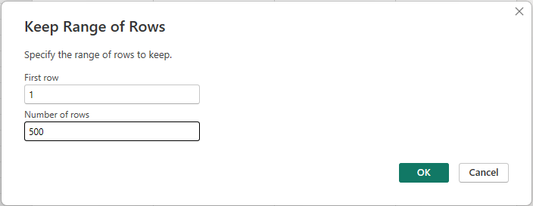
I imported the data as an .xlsx file, and Power Query automatically sorted the rows, displaying only the first 500 records
- Ensure the “Order Date” column in the “List of Orders” table is set to data type 'Date'.

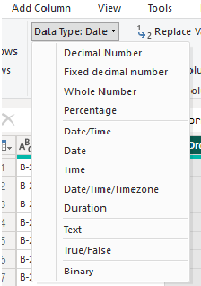
- Change the data type of “Amount” and “Target” columns to ‘Fixed Decimal Number’.
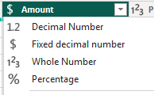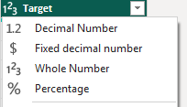
- Format the "Customer Name" column into proper case, ensuring consistent capitalization for each word.
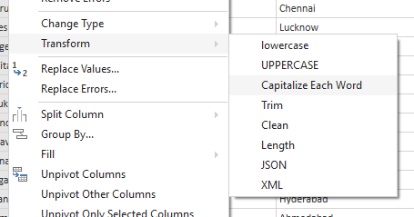

- Merge the "State" and "City" columns to create a new column named "Location" in the format ‘City, State’.

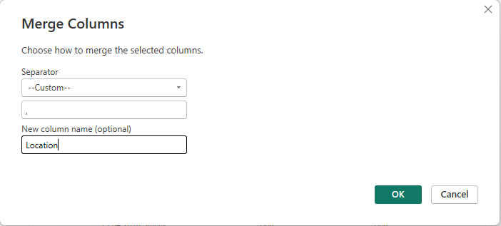

- Create a new custom column named "Profit Margin" as the percentage of "Profit" divided by "Amount".
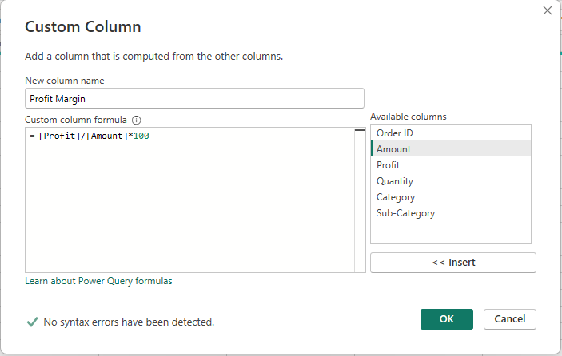
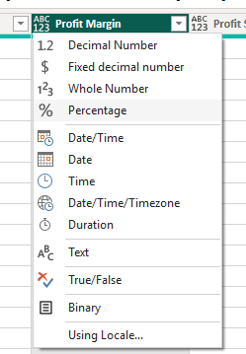

- Add a new conditional column named "Profit Status" based on the values in the "Profit" column. The conditions are as follows: if the profit is less than 0, the label should be "Loss"; if the profit equals 0, the label should be "Break-Even"; and if the profit is greater than 0, the label should be "Profit".
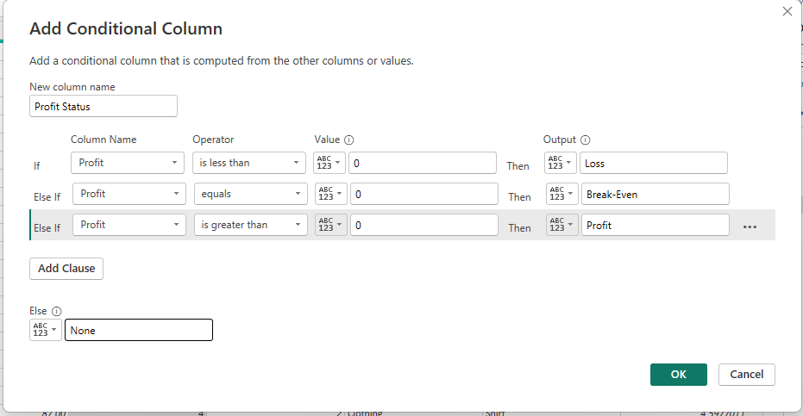
- Merge the "List of Orders" and "Order Details" tables into a new single table named "Orders Data" based on the "Order ID" relationship.
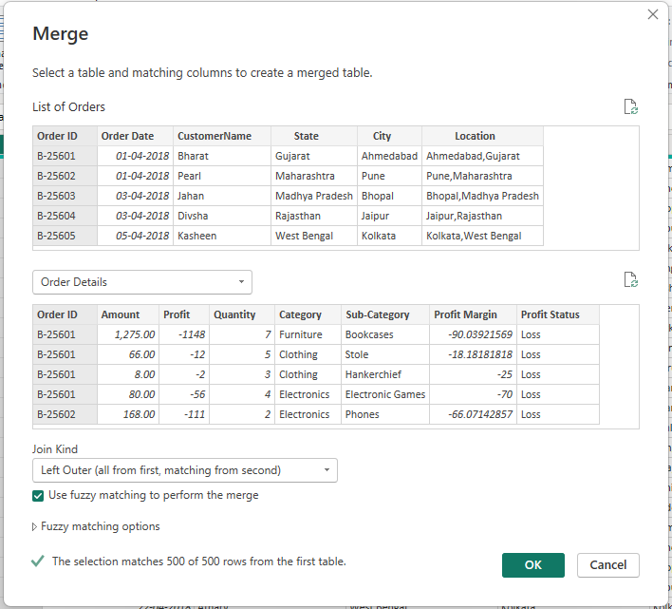
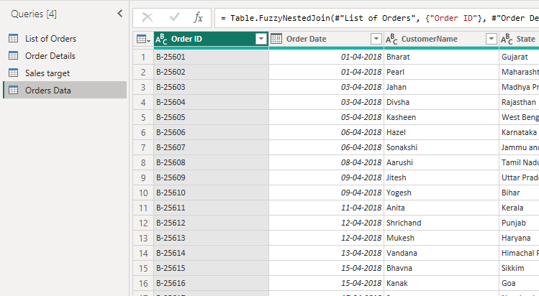
- Handling Missing Data & Duplicate Data
Checked all columns and tables for data quality.
Using Home → Remove Rows → Remove Duplicates, no duplicate records were found.
I also verified that no missing or null values existed in the dataset.

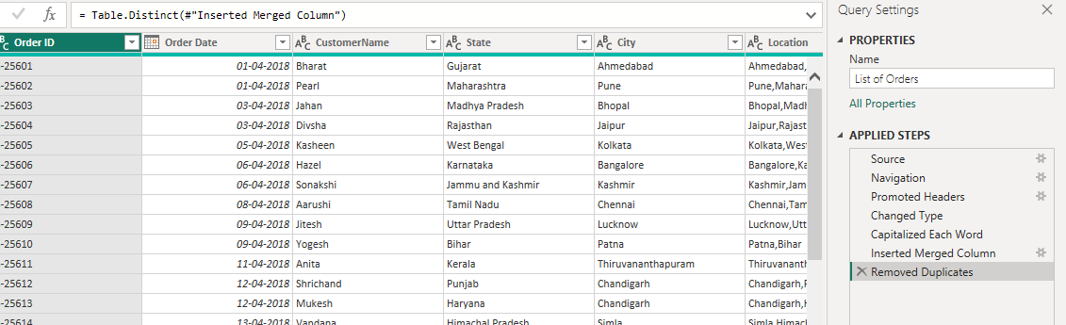

Sorting and Filtering Data:

- In the ‘Orders Data’ table, utilize sorting and filtering techniques on columns like Order Date, State or Category to analyse data based on specific criteria:
- Sort the orders by Order Date in descending order to analyse recent trends

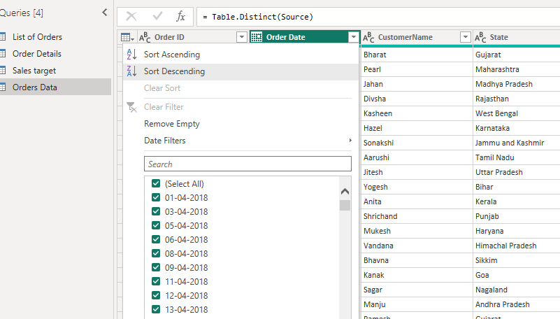

- Filter the orders to focus only on a specific state (e.g., Tamil Nadu) for regional analysis.

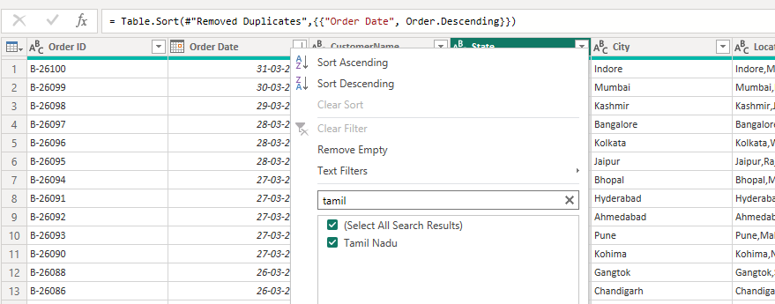

Grouping and Aggregating Data:

- Duplicate the “Order Details” table and calculate the count of each Order ID, average profit by Category or total amount by Sub-Category.
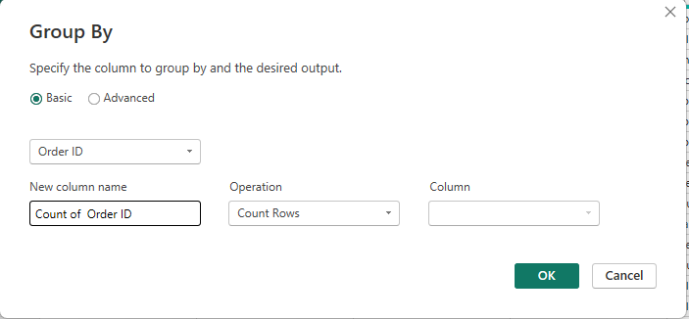
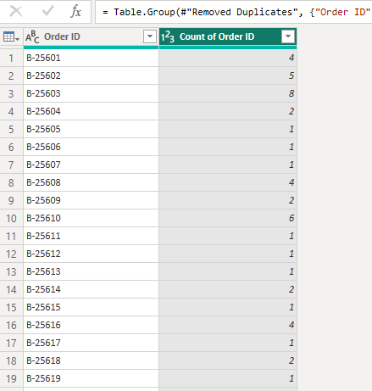
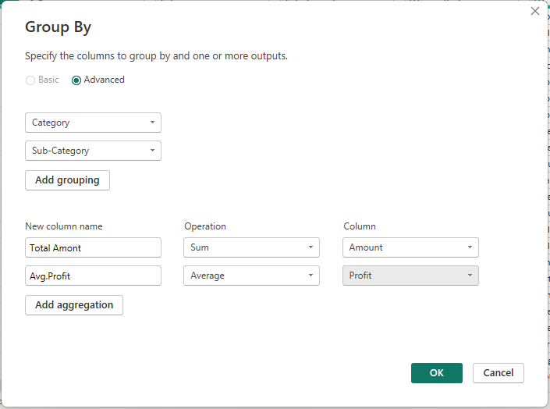
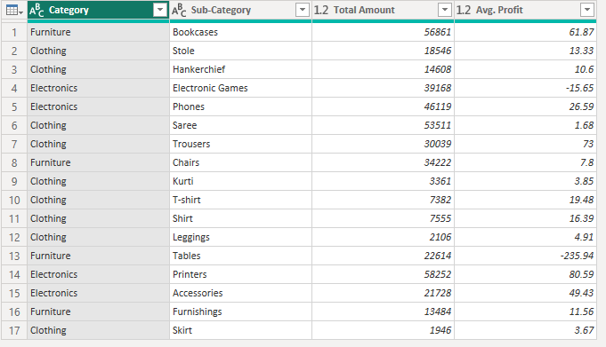

- Duplicate the “Sales Target” table and aggregate the total target amount by Month of Order Date.

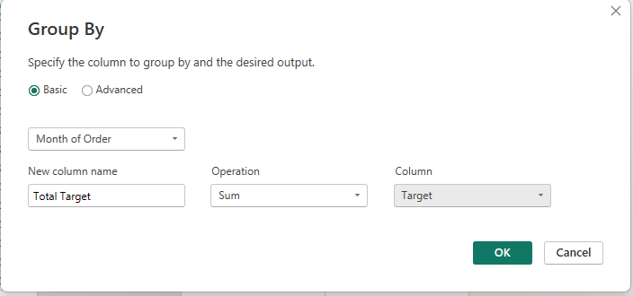

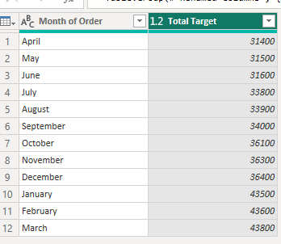

- Finally, selected Close & Apply to import the transformed data into Power BI

Data Modelling:

- Save and Moved the Data to PBI
- After saving, Power BI automatically generates a default table layout along with the initial relationships.
- Establish a relationship between the “List of Orders” and “Order Details” tables using the ‘Order ID’ column.
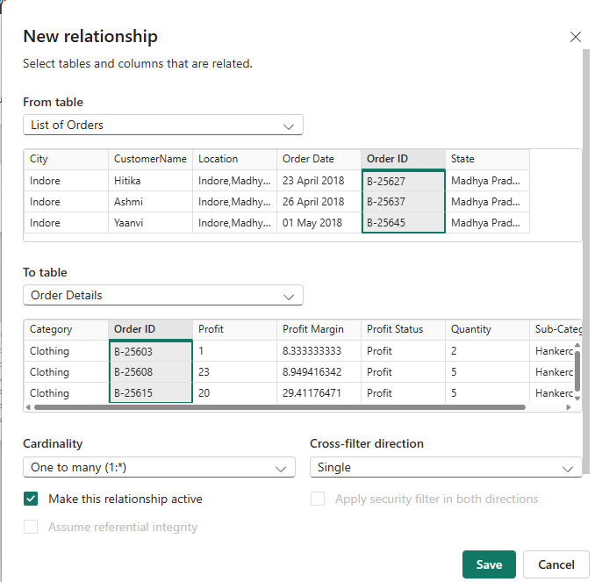
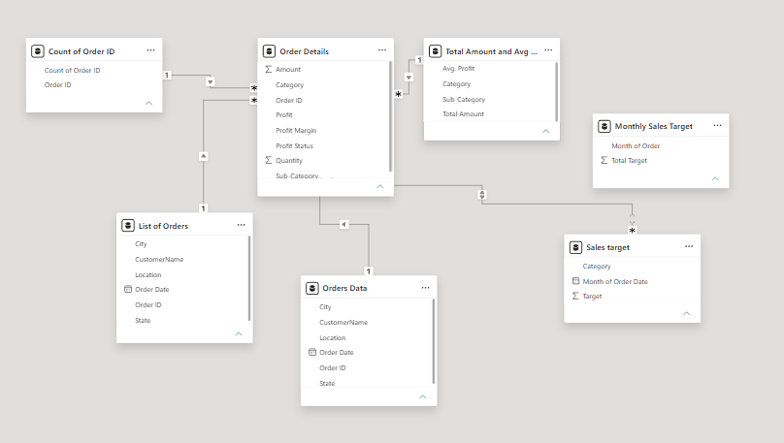

- Build a relationship between the “Order Details” and “Sales Target” tables based on the ‘Category’ column. Click "Manage relationships" and ensure this relationship is active.
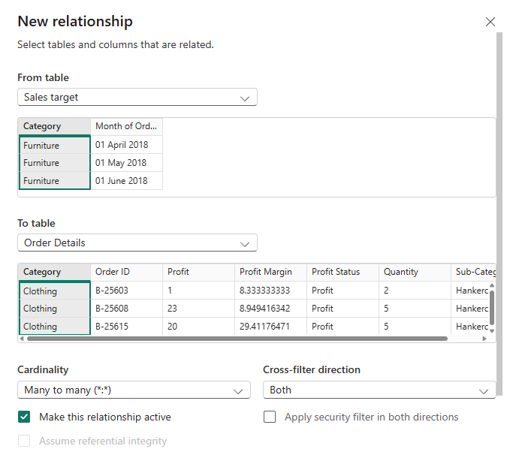

- Click "Manage relationships" and ensure this relationship is active.
